Report to Members of the Parish Council

TO: | Members of the Parish Council
MEETING DATE: | 28th November 2022
SUBJECT: | Cllr Jilly Jordan November 2022 Update
REPORT AUTHOR: | Chloe Collins

Agenda item No: 1

Cllr Jilly Jordan update Nov 2022

Bank Holiday bin collections across Buckinghamshire
​
It’s the season of giving – and recycling! As usual, bin collections across Buckinghamshire will be operating to a revised timetable over the Christmas Holiday period. As we produce around 30% more waste during the holiday period, it’s important to reduce, reuse and recycle while we enjoy the seasonal festivities. You can make good use of leftover food, donate unwanted gifts and recycle Christmas cards and other Christmas packaging – there is some great and cost-effective ways to be environmentally friendly over Christmas.
Here are some Christmas items you can recycle at home for a greener Christmas:
- Christmas cards and crackers (without the snap)
- Paper hats
- Non-glittery wrapping paper
- Chocolate boxes
Please ensure you fold and flatten cardboard to a manageable size and place any extra cardboard securely next to your recycling container. Please also remove any other packaging, like polystyrene or Sellotape!
After the festive season is over, you can also dispose of your Christmas tree, wreaths, holly and mistletoe with our garden waste collection service. If you are a garden waste customer, you can simply remove all decorations, cut the tree into smaller pieces, and place the pieces in your garden waste bin. If you are not currently subscribed to our garden waste collection service, you can either take the tree to your nearest household recycling centre or see if there is a local charity collection near you.
Buckinghamshire’s Household Recycling Centres will be closed on Christmas Day, Boxing Day and New Year’s Day.
All other days over the Christmas period, whether Bank Holidays or not, our sites will operate the usual opening days and hours (9am-4pm). Check online before you visit to confirm opening hours and avoid the queues. You can visit our website for all the latest Household Recycling Centre information.
During the festive period, bin collections across Buckinghamshire will be operating with a slightly altered timetable. Collections due to take place on Monday 26 December (Boxing Day) will move to Wednesday 28 December. Collections due to take place on Tuesday 27 December (Christmas Bank Holiday) will move to Thursday 29 December, and collections from Monday 2 January (New Year Bank Holiday) will be collected Wednesday 4 January. Please check the revised timetable below and present any bins or containers by 6:30am on the revised collection day.
Garden waste collection service will also operate with an alternative timetable, as from Monday 12 December to Sunday 22 January 2023 (inclusive) our garden waste collection service will be suspended for six weeks. Collections will resume from Monday 23 January 2023.
Christmas bank holiday collections:
Usual collection day | Revised collection day
Monday 26 December (Boxing Day) | Wednesday 28 December
Tuesday 27 December (Christmas Bank Holiday) | Thursday 29 December
Wednesday 28 December | Friday 30 December
Thursday 29 December | Saturday 31 December
Friday 30 December | Tuesday 3 January
Monday 2 January (New Year Bank Holiday) | Wednesday 4 January
Tuesday 3 January | Thursday 5 January
Wednesday 4 January | Friday 6 January
Thursday 5 January | Saturday 7 January
Friday 6 January | Monday 9 January
Monday 9 January | Tuesday 10 January
Tuesday 10 January | Wednesday 11 January
Wednesday 11 January | Thursday 12 January
Thursday 12 January | Friday 13 January
Friday 13 January | Saturday 14 January
For more information including how to check your Bank Holiday bin collections and many useful recycling tips, you can visit: buckinghamshire.gov.uk/bank-holiday-bins

You can also follow @BucksCouncil to keep up-to-date with the latest recycling & waste and bin collection information on our Facebook and Twitter pages.

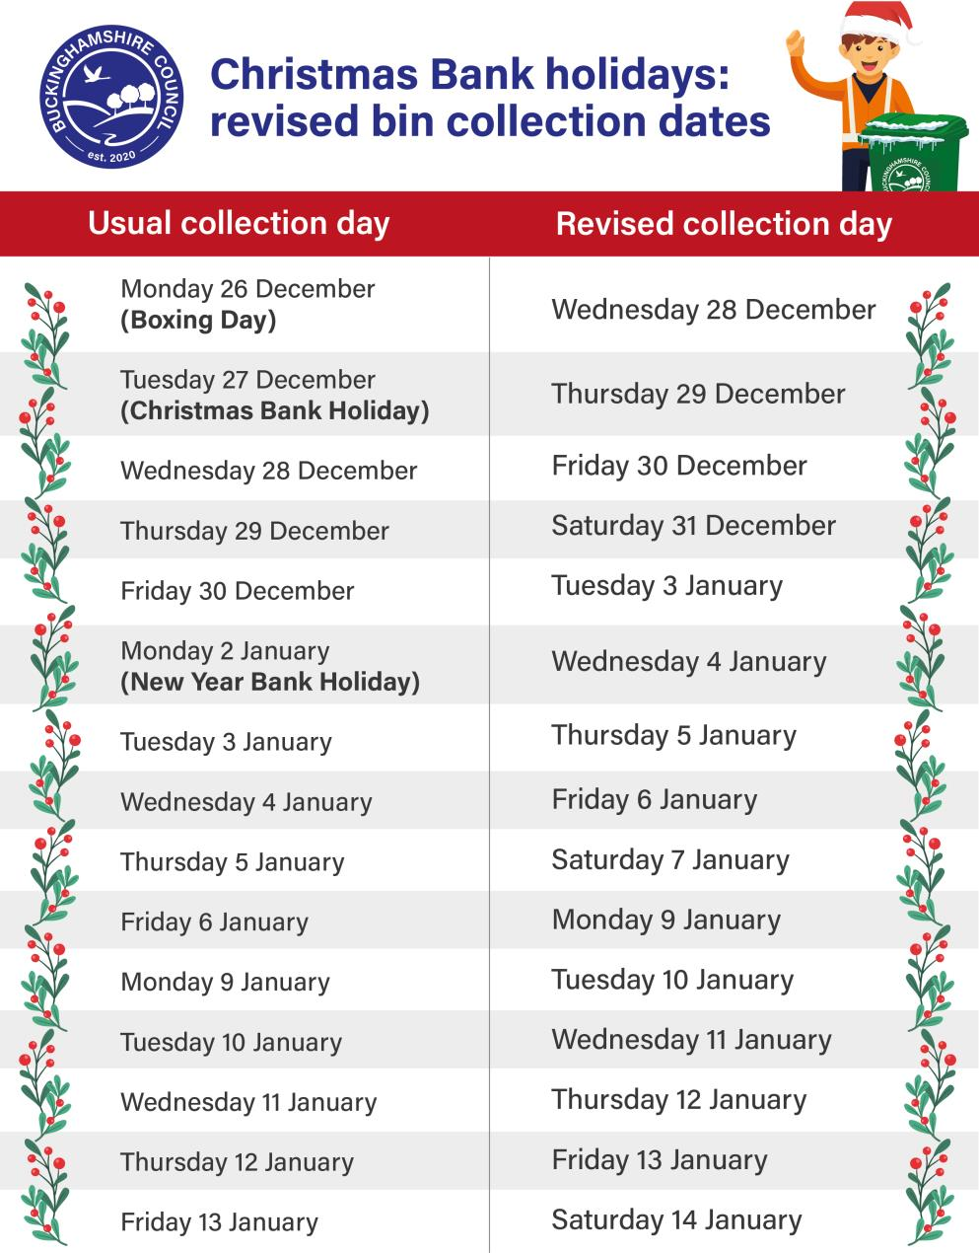
Image: Christmas Bank Holidays: reversed bin collection dates
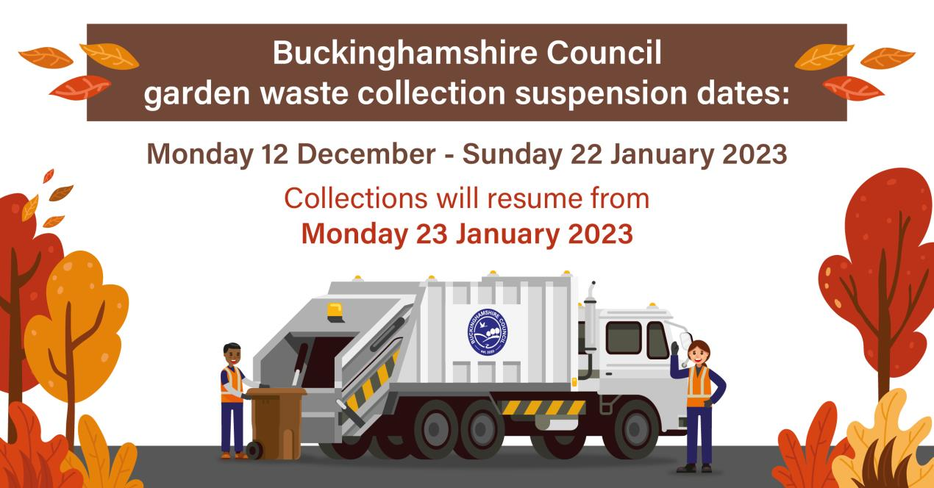
LitterLotto Local launched to reward Buckinghamshire residents for binning litter
Buckinghamshire Council has worked with LitterLotto to launch an extra monthly prize for residents who do the right thing and bin their waste. By working closely with LitterLotto to create a geofence around Buckinghamshire, the council can now reward local people who bin their rubbish and help keep litter off the streets and out of our beautiful countryside.
The council has worked with LitterLotto since it launched in the UK in 2021. LitterLotto is a free to enter prize draw with regular spot prizes and huge jackpots. To enter, residents simply use the app to take a picture of litter as they place it in a bin. Each time they submit a new piece of litter it's another chance to win. 85% of litter binned via the app is ‘fugitive’ rubbish that was on the floor, hedge or out in the environment. The more local users the app has, the more litter will end up in the right place - the bin.
The new LitterLotto Local initiative sees an extra monthly prize draw of £250 just for binning litter in Buckinghamshire. By introducing an extra prize draw the council hopes to reward people who bin their litter and hopefully encourage more people to bin it to win it.
Gareth Williams, Buckinghamshire Council’s Cabinet Member for Environment and Climate Change, said:
“We spend £2.5million cleaning the streets of Buckinghamshire and unfortunately, much of the tidying up is picking up litter, despite having over 4,000 bins emptied regularly across the county. With the new LitterLotto Local initiative, we want to encourage people to protect their surroundings and reward the right behaviour. If we can get more litter in bins, we can save some money that we are currently spending litter picking and divert it to other projects or services.
“So many residents already take time to litter pick their local areas, and for those people this is a recognition of that. Sadly, some people still drop litter, and we hope this will encourage them to rethink their actions.”
David Landsberg, Founder and CEO of LitterLotto, said:
"We’re proud to be working with Buckinghamshire Council to launch our new LitterLotto Local initiative. The council has always been at the forefront of adopting new methods and pushing boundaries to address littering and were instrumental in helping us shape our offering. We’re looking forward to working with them to create an even more beautiful Buckinghamshire, with less litter."
The initiative with LitterLotto launches 1 November and will run for 12 months across the county. Local groups, individuals, businesses or Town & Parish Councils who wish to spread the word about LitterLotto Local can email waste_strategy@buckinghamshire.gov.uk to receive a supporters pack, including posters, stickers and digital content.

Can you offer a spare room in your home for a Ukraine guest?
The dreadful war in Ukraine continues and the most recent development has been the targeting by Russia of Ukrainian power supplies, leaving many towns and cities without lighting or heating during autumn and winter. This obviously means it is difficult for Ukrainians to consider returning to their homes. The generosity of Buckinghamshire residents has been amazing since Ukrainian families and individuals began arriving in the county, with many residents offering to host people from Ukraine, providing not just accommodation, but a warm welcome, a network of support and help with settling into the UK. While many sponsors are happy to extend to 12 months, for some it isn’t feasible to continue beyond the first six months.

Sponsors have told me that they have found the experience hugely rewarding and, in some cases, very positively life changing. As our first Ukrainian guests arrived at the end of March 2022, and with over 1,400 guests having arrived so far, we now need new sponsors for many of these families.

There is a ready-made network of support groups from Beaconsfield to Buckingham, including the Marlow Ukraine Collective, Friends of Ukraine at the Vineyard and Hilltops Ukrainian Support Community to name a few.

Each sponsor who accommodates a Ukrainian guest has a Council Liaison Officer to help with any queries or issues and receives a £350 a month 'thank you' payment which is payable for up to 12 months after guests arrive in the UK.

If you are interested please contact our Ukraine Team by emailing: ukrainesupport@buckinghamshire.gov.uk

£3m to help eliminate rough sleeping

We’re really proud that in Buckinghamshire we’ve seen the numbers of people sleeping rough come down to very low levels. Supporting people facing homelessness and eliminating rough sleeping is a key manifesto commitment of the council. Therefore, it’s great news that we’ve successfully secured nearly £3 million in new, targeted funding to help achieve the overall aim of having no one necessarily sleeping rough in Buckinghamshire.

This money will be used to help target the root causes behind why someone becomes homeless and will go towards mental health, drugs and alcohol support, as well as providing more emergency beds to help people off the streets.

Last chance to comment on constituency boundaries

The Boundary Commission for England has recently published its revised proposals for constituency boundaries across the country. Comments on the proposals can be submitted up until 5 December. The proposed new map can be viewed online where comments can be submitted.

Can you help promote the Christmas toy appeal?

With greater pressure than ever on family finances we want to do what we can to ensure our most vulnerable children and young people don’t miss out this Christmas. That is why we have once again joined forces with local charity, Inspire Bucks, to raise funds for gifts for children in touch with our social care service.

The initiative is always a great success. Last Christmas more than 2,000 Buckinghamshire children and young people with disadvantaged backgrounds received presents thanks to the generosity of local donors, who pushed funds well over the target of £10,000. During the past year funds have also allowed birthday gifts to be given to 200 children.

Donating is simple, just go to the GoFundMe page and Inspire Bucks and our social services team will do the rest, helping to ensure a happy Christmas for children and young people across Buckinghamshire.

Help shape our vision for libraries

The previous item on welcoming spaces just shows how important our libraries are as community hubs. Over a million items are borrowed every year from Buckinghamshire Libraries and they provide diverse services, from book lending, to reading groups, digital access and local events and activities – plus much, much more.

We want our libraries to continue meeting the needs of our communities so are seeking views on what the priorities should be for Buckinghamshire’s libraries. We want as many people as possible to take part in this survey, not just current library users so please spread the word and take part in the consultation too.

It’s open until Sunday 15 January at www.buckinghamshire.gov.uk/libraries-your-views

Are your residents ready for winter?

With temperatures dropping and weather conditions likely to turn more unpredictable as we approach winter, we are asking local residents to think about what they can do to prepare for the worst of the cold season in order to keep themselves and their loved ones safe and well. From knowing how to report an issue such as a flooded road to keeping items such as wellies and snow shovels handy, there are lots of tips people can take note of to ensure they are fully prepared. Find out more on our website.

More trees please!
National Tree Week is approaching, starting on 26 November and once again we are using the focus to plant more trees around the county, and we need your help!
Working in partnership with Chiltern Rangers, we are inviting residents to help us plant 4,000 hedgerow plants and trees along the Platinum Way Greenway in Aylesbury as part of a £1.4m upgrade.

Please invite your local community to get involved. Anyone who would like to take part in the planting which takes place between 30 November and 9 December – even just for a couple of hours – can email info@chilternrangers.co.uk. They will then forward further details of each day's location for planting.

Details on the different events can also be found on Eventbrite, just search for Platinum Way at: www.eventbrite.com

Deadline for cashing council tax energy rebate vouchers is approaching
Earlier this year the Government announced that all households in council tax bands A to D would receive a £150 payment as part of a range of measures to support people with the rising cost of energy pressures. Residents who were eligible for an energy rebate who had not received a BACS transfer were sent a voucher in the post in August this year. The vouchers need to be taken with a form of photo ID, to a post office, where they can be exchanged for £150.

The deadline for cashing the vouchers is Wednesday 30 November. Our latest figures show that around 3,600 vouchers are still waiting to be cashed in Buckinghamshire so please could you to urge residents in your area who haven’t yet cashed their vouchers to do so before it is too late.

The process is fully explained in the voucher letter and on the council website.

