Cllr Jilly Jordan & Cllr Caroline Cornell 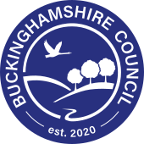

Drayton Parslow Parish Council Meeting, Monday 30th^{th} June 2025

Buckinghamshire Council’s Cabinet holds first meeting
​
Buckinghamshire Council’s new Cabinet has held its first meeting (Tue 17 June), during which the council’s overall performance and stable budget position were reflected on.
A number of key reports were discussed and considered by the new Cabinet, including the council’s Annual Report and a summary of its financial performance during the 2024/25 financial year.
The Cabinet recognised the excellent level of achievement and firm foundations the new council has inherited following the May elections, and paid tribute to the work of the previous administration.
Council Leader Steven Broadbent highlighted a number of achievements in the Annual Report, which covers the full range of services and projects delivered under Buckinghamshire Council’s four core priorities:
- Strengthening our communities
- Protecting the vulnerable
- Improving our environment
- Increasing prosperity
The annual report is an update on the over-arching Corporate Plan which acts as a golden thread for all the work and services that the council delivers to improve lives and have a positive impact on Buckinghamshire and its people.
The Cabinet also considered the ‘2024/25 Budget outturn’ report which documents the significant achievement in balancing last year’s budget against a context of considerable pressure and volatility. While portfolio budgets were overspent by £6.5m, primarily from Children’s Social Care, Home to School Transport and a smaller than forecast income from parking services, these were offset by overall savings made across the council’s spending.
Overall, the council successfully delivered £147.1 million of investment during 2024/25 on capital schemes, progressing major projects such as new South East Aylesbury Link Road and key town centre improvements that include the upgrade of White Hart Street in Wycombe and the creation of the new ‘Pavilion Quarter’ in Aylesbury Town Centre.
Commenting, Buckinghamshire Council Leader Steven Broadbent said:
“It’s been really good to reflect on the overall position of this council that my new administration has taken on as we get our work underway. During the Cabinet meeting I was keen to pull out some of the detail within the Annual Report to raise wider awareness of the breadth of the work of this council and the improvements and initiatives we are delivering every day. I urge residents to read the Annual Report to get a full picture of where their council tax is being spent. New school places, tackling loneliness, equipping leisure centres with solar power; these are just a small snapshot of the detail within.
“We also welcomed the solid financial performance of Buckinghamshire Council, ending the last financial year with a balanced budget amidst significant pressures on local authority finances. This is testament to our careful management of taxpayer’s money in Buckinghamshire.
“We still have to make tough choices and we are legally obliged to deliver a balanced budget, which we’ve only been able to do by delivering substantial savings of £116.5 million since becoming a unitary council in 2020.
“I am committed to providing our residents with the best, most efficient and cost-effective services we can - from those that touch everyone’s everyday lives like bin collections and roads and transport to those support services that some of our residents rely on. The budget is in a good place through robust and meticulous management allowing us to take forward our plans, with our residents’ priorities and value for money at the heart of all we do.”

Buckinghamshire Council libraries launch new Carer’s Card
​
Following a successful ‘CareFest’ in Buckinghamshire libraries – the first week of its kind, a new library card has been launched for carers. The new card, beautifully designed by local young carers, provides a new library membership category tailored specifically to Buckinghamshire carers.
This new category offers two key benefits: no overdue fees and an extended loan period of an extra week. The Council recognises that carers often face unpredictable schedules and responsibilities, which can make it difficult to return items on time. By removing the pressure of fines and giving them more time, the initiative aims to make it easier for unpaid carers to access and enjoy library resources without added stress.
The card was launched during CareFest - a vibrant, week-long festival celebrating the vital contributions of unpaid carers across the county. Organised by Carers Bucks and supported by Buckinghamshire Council through its Healthy Libraries programme—a partnership between Public Health and the library service—this inaugural event added a new dimension to the Council’s ongoing support for carers.
Held during Carers Week last week, (Monday 9 June to Friday 13 June), CareFest brought together carers from across Buckinghamshire to connect, learn, and take part in a wide range of free activities. With events hosted in libraries across the county and additional sessions available online, the festival was designed to be inclusive and accessible to all. Attendees enjoyed well-being sessions, heard from inspiring guest speakers, and explored engaging information stands.

First civil enforcement penalties issued for littering from vehicles in Buckinghamshire
​
Buckinghamshire Council has issued its first fines to people captured in the act of littering from their vehicles using newly adopted civil enforcement powers.
The initiative, which forms part of the council’s wider For Bucks Sake anti-littering campaign, aims to crack down on roadside littering and hold vehicle owners accountable for waste thrown from their cars.
The new powers, under the terms of the Littering from Vehicles Outside London (Keepers: Civil Penalties) Regulations 2018, allow the council to issue a Penalty Notice (PN) to the registered keeper of a vehicle from which litter is thrown, regardless of who committed the act. Buckinghamshire Council is one of the first councils in the country to implement this process which is more streamlined and quicker than the criminal route to prosecution but still sends a strong message to anyone who may be tempted to litter.
All three cases resulted in a penalty notice for £500 being issued. In the first case, dating from 4 April 2025, a van driver was caught on roadside CCTV discarding litter from the passenger side footwell while parked on the A412 in Denham. The footage was sent to the vehicle owner, and the fine was deducted from the drivers’ wages.
The second incident took place in Bierton on 26 April 2025 when a driver threw a water bottle from his window on the A418. The offence was captured by a dashcam in the vehicle behind and submitted via the council website.
In the final case, in Iver on 15 May 2025, a small sack of litter was thrown from a moving vehicle on the A412, scattering waste across the road and hedgerows. The incident was once again captured by roadside CCTV.
In all three cases the maximum fine of £500 was given - and paid in full.
Last year the council launched the For Bucks Sake campaign to combat littering. As part of the initiative, drivers are asked to submit dashcam footage if they record evidence of littering from vehicles. Submissions must clearly show the offence and the vehicle’s registration number. Evidence can be uploaded on the council website.
All income from fines is ring-fenced for environmental enforcement and street cleansing.
To submit dashcam evidence visit: https://www.buckinghamshire.gov.uk/parking-roads-and-transport/report-problems-on-roads-streets-and-pavements/report-littering-from-vehicles/#:~:text=If%20you%20see%20someone%20littering,registration%20details%20of%20the%20vehicle

Council cracks down on drivers misusing disabled parking permits
​
Buckinghamshire Council has conducted a successful partnership operation with teams across Parking Enforcement, Fraud, Blue Badge, along with Police Community Support Officers (PCSOs), coming together to tackle the misuse of Blue Badges.
The enforcement initiative took place across car parks and on-street parking restrictions in Aylesbury, Amersham, Chesham, and High Wycombe, focusing on identifying and addressing the abuse of Blue Badge permits, along with educating motorists on the inappropriate use of disabled bays.
The operation coincided with the national Blue Badge Day of Action on 30 May, when local authorities across the country united in a collective effort to tackle misuse of the scheme. Buckinghamshire Council extended its activity through to 3 June, reinforcing its commitment to protecting the integrity of the Blue Badge system.
During the operation, a total of 151 Blue Badges were inspected. As a result, 23 Penalty Charge Notices (PCNs) were issued. Additionally, over 60 information leaflets were distributed to Blue Badge holders, offering guidance on how to protect their permits from theft or improper use.
Investigations are ongoing, and prosecutions may follow where appropriate.

If you suspect someone is misusing a Blue Badge, you can report it confidentially to the council.

Community Safety

We receive regular updates from the Neighbourhood Policing Team (NHPT) with useful information about crime and crime prevention initiatives in our area, which will be shared with you as appropriate.

Update from Buckinghamshire Local Command Unit

Neighbourhood Policing in Buckinghamshire will see a boost in officer presence across Aylesbury, Wycombe, Chesham, and Burnham, with eight new team members expected to arrive in September. This initial allocation, made by Thames Valley Police, is based on strict criteria, with the distribution designed to reflect current priorities and operational need. These additions are intended to strengthen efforts around retail crime, a key national priority.

Town and Parish Council customer service VIP line

You can make contact with us via the following email address: parishsupport@buckinghamshire.gov.uk
There is a dedicated Town and Parish Council customer service VIP phoneline where you can reach a member of our customer team on 0300 303 5640, 9am to 5:30pm Monday to Thursday, and 9am to 5pm on Friday.
Jessie Bath, Member Liaison Officer
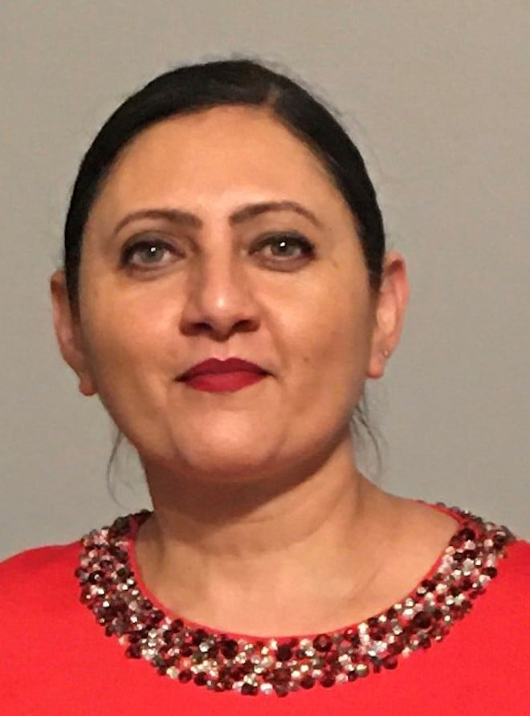
  Jessie Bath is a Planning Senior Business Support Officer, working within the Member Liaison Office for the Planning & Environment area.
  She supports Members, Town & Parish Councils and the Planning & Environment teams to answer questions/enquiries they may have.

Planning & Environment covers the following areas:

- Planning – Development Management
- Planning – Major Developments
- Planning Enforcement
- Planning Policy (i.e. NPPF (National Planning Policy), 5 Year Land Supply, S106, Neighbourhood plans)
- Heritage and Archaeology
- Ecology
- SuDs – Strategic Flood Management
- Building Control
- Highways Development Management
- TPO’s (Tree Protection)
- Landscape and Urban Design

One of the avenues to support communications between Town & Parish Councils and Officers are the Planning Surgeries, which we first set up in August 2023.

Schedules for these are circulated before each quarter, and the surgeries are well worth you attending if you need any Planning & Environment support, or if you just want to know more about the service.

Additionally, and you may already be aware of this, but we hold annual Town & Parish Councils forums, where our Planning & Environment teams give updates on each area and cover any policy or legislative changes you should be aware of.

To find out more about our Member Liaison Officers, email: memberliaison@buckinghamshire.gov.uk



Cllr Caroline Cornell Buckinghamshire Council Cllr Jilly Jordan Buckinghamshire Council
Email: Caroline.Cornell@buckinghamshire.gov.uk Email: jilly.jordan@buckinghamshire.gov.uk
Mobile: 07976853643 Mobile: 07740308468

