Cllr Jilly Jordan & Cllr Caroline Cornell 

Drayton Parslow Parish Council Meeting, Monday 29th Sept 2025

Council announces Children’s Services Improvement Plan
​
Buckinghamshire Council has formally agreed a comprehensive Improvement Plan to strengthen services for vulnerable children and young people, following the latest Ofsted inspection of its Children’s Services.
The Plan was approved at the Cabinet meeting on 9 September and sets out a clear roadmap to address areas identified for development in the inspection report published earlier this year.
Ofsted visited the council between 27 January and 7 February 2025 to assess services for children in need of help and protection, children in care, and care leavers. While the overall judgement remained “requires improvement to be good”, inspectors rated the experiences and progress of children in care as “good” and acknowledged significant progress since the previous inspection in 2021.
The Improvement Plan builds on this progress and outlines targeted actions to improve consistency, strengthen management oversight, and enhance support for care leavers and children at risk of neglect.
Key areas of focus in the Improvement Plan include:
- Strengthening management oversight and reflective supervision
- Improving support for children at risk of neglect
- Enhancing transition planning for older children and disabled care leavers
- Increasing engagement with care-experienced young people
- Improving the quality and consistency of pathway plans for care leavers aged 21+
The plan will be monitored through a robust framework of quality assurance and performance review, with progress reported regularly to Cabinet, the Children’s and Education Select Committee, and the Corporate Parenting Panel.
The full Ofsted report is available here.
–

Council launches ambitious Growth Plan to drive economic prosperity
​
Buckinghamshire Council has launched its new Economic Growth Plan for 2025–2035, setting out a bold vision to boost the county’s economy over the next decade.
Approved by Cabinet on 9 September, the Plan aims to deliver annual productivity growth above 2% by 2035, focusing on high-value sectors such as space, creative industries, high-performance technology, and life sciences. It also includes valuable, targeted support for small and medium-sized enterprises (SMEs) through business development programmes and strategic partnerships.
The strategy was unveiled at the Buckinghamshire Economic Summit held at Pinewood Studios on 11 September, where business leaders, investors, health, and education partners came together to explore opportunities for closer collaboration supporting new growth and innovation. The Summit also launched the county’s Investment Pipeline – a portfolio of major projects designed to attract public and private investment.
Steven Broadbent, Leader of Buckinghamshire Council, said:
“Buckinghamshire is home to world-class industries and incredible talent, and this Plan sets out how we will unlock that potential. At our Economic Summit, we heard from businesses and partners about the opportunities ahead – from pioneering space technologies at Westcott to cutting-edge film production at Pinewood and high-performance engineering at Silverstone.
“Taking a lead on promoting the excellence and strengths of Buckinghamshire and its people is paramount. These projects are not just about growth in isolation, they’re about creating skilled jobs and opportunities, supporting our bedrock of impressive companies and SMEs, and ensuring Buckinghamshire remains a fantastic place to live and thrive. By working together, we can build a stronger, more innovative economy that benefits everyone.”
Flagship projects in the Investment Pipeline include:
- Westcott Space Cluster – A national hub for advanced space technologies, with plans for a National In-Orbit Servicing, Assembly and Manufacturing (ISAM) Facility and a National Drone Centre of Excellence.
- Silverstone Technology Cluster – A global centre for high-performance engineering, including a proposed Silverstone Incubator Village to drive R&D in new propulsion and advanced materials.
- Pinewood Studios & Creative Cluster – Home to blockbuster productions and the upcoming CoSTAR National Lab, an R&D facility that will put the UK at the forefront of immersive storytelling technologies – including gaming, virtual reality and on-screen entertainment.
- Town centre regeneration – Major redevelopment opportunities in Aylesbury and High Wycombe town centres, helping create vibrant mixed-use spaces, attractive environments and new commercial opportunities.
The Economic Growth Plan also commits to overcoming barriers to work for people and restrictions on business growth, including improving connectivity, investing in skills, and supporting SMEs through tailored business programmes. It aligns with the UK’s Industrial Strategy and positions Buckinghamshire as a key player in sectors critical to the national economy.
The Plan has been designed to provide the framework to help build a productive, inclusive, and resilient economy, aligning with the new National Industrial Strategy, to increase annual productivity growth and ensure that communities benefit from better jobs, infrastructure, and opportunities across Buckinghamshire.
It outlines five strategic priorities: growing high-value sectors such as space, film, engineering and life sciences; enhancing place and infrastructure, particularly in town centres and by improving connectivity for transport and housing; investing in people and skills through education, training and employment; encouraging innovation in areas like AI and R&D; and strengthening local and regional partnerships.
The Buckinghamshire Economic Growth Plan is available to view online.

Tackling and preventing domestic abuse is everyone’s business

Free training is available

Every 30 seconds in the UK, the police receive a domestic abuse related call. Domestic abuse makes up 18% of all recorded crime in England and Wales and in the UK a woman is killed by a man every 3 days. Two million women are estimated to be victims of violence perpetrated by men each year. While men and boys also suffer many of these forms of abuse, they disproportionately affect women.
Cases of Domestic Abuse (DA) and Violence Against Women and Girls (VAWG) continue to be seen in Buckinghamshire, and everyone has a responsibility to play a part in recognising and calling out the signs of domestic abuse to protect those at risk and provide a safe environment for everyone living, working, and visiting Buckinghamshire.
Going from strength to strength, Buckinghamshire Council’s fully funded multi-agency ‘Tackling and Preventing Domestic Abuse’ training catalogue has published its fourth offering for Buckinghamshire for 2025/26.
This year’s offer includes eight new topics derived from local Buckinghamshire insight on DA and VAWG cases, including: being trauma informed, stalking and cyber stalking, post separation abuse, responding to disclosures, Buckinghamshire referral pathways, protective orders, mental health and suicide prevention, and understanding risk and managing safety.
The training catalogue is for anyone wishing to upskill their knowledge around domestic abuse and is not exclusively for professionals who work with vulnerable or at-risk audiences. The aim is to increase people’s confidence in identifying the signs of abuse and give appropriate support and signposting to victims. Whatever your role, whether you manage a team, teach, own a business, run a community organisation or work in the health, adult social care or children’s services sectors, these courses could help you challenge and change behaviours and help victims get the support they need, sooner.
The offer continues to be entirely free of charge to encourage as many individuals as possible to improve or refresh their knowledge. The training is a mixture of ‘power hours’, half and full day sessions. Power hour virtual sessions are delivered to encourage higher levels of attendance. Most of the courses in the catalogue are online to fit in with evolving working patterns.
To view the training catalogue and details of how to register for the courses, please visit the following webpage: bucksdap.org.uk/training-learning/bucks-training-catalogue

Council to invest in new and improved day care and expanded overnight respite facilities to support adults with complex needs and disabilities
​
Buckinghamshire Council’s Cabinet has on Tuesday 9 September approved a new and improved model for how it provides day care and overnight respite services for adults with disabilities and complex needs. The proposal includes investment in both new and existing facilities to enhance specialist provision for supporting people across the county.
The new service model will ensure that we have the right balance of different types of services delivered in our communities, alongside services from buildings, to meet need now and for the future. This includes providing high quality building-based facilities within reasonable distance for the smaller number of adults with complex needs for whom building-based care is essential.
The current service model is outdated with an over-reliance on building-based care that is underused in many locations. Data showed that in recent years, use of many of the council-run day centres has dramatically fallen, while the level of community-based and partner-led provision available has grown, both in number and popularity.
The council carried out a comprehensive 15-week consultation over the proposed changes and the feedback received was used to design the new care model.
Isobel Darby, Buckinghamshire Council’s Cabinet Member for Health & Wellbeing, explained: “Throughout this process we have kept our service users and their families at the heart of our approach. As a carer myself, I fully understand how important this provision and these facilities are to our communities. It was therefore very important to us to ensure we listened closely to the thoughts and views of those who use these services so we could ensure that any new model would continue to meet their needs and give them access to the right level of support they require.”
Isobel continued: “As a result of the feedback received, we have changed the original proposal to close Seeleys House and have instead decided to keep this facility open. We are grateful to everyone who took the time to take part in the consultation. We always listen closely, and this example shows that by listening and working together, we can create a high-quality service that fully meets the needs of all our residents. Crucially, this is also about looking at a model that provides best value for money for all Buckinghamshire residents and taxpayers. Today’s decision means we can keep looking after the adults who need these services whilst directing funds away from buildings that are being under-used and back into other services that are also very important to our residents.”
In the meeting today, the following recommendations were agreed:
- Support for adults with multiple and complex needs will be provided at four existing, upgraded council run sites: Aylesbury Opportunities Centre, Chesham Day Centre, Spring Valley Day Centre (High Wycombe) and Seeleys House.
- The opening of a new, specialist overnight respite centre for adults under 65 in Aylesbury to provide better geographical coverage across the county, alongside the existing facility in Beaconsfield (Seeleys House).
- Setting up a dedicated learning disabilities team in adult social care to enhance specialist support.
- Repurposing of the Buckingham Day Centre for use for up to 30 young adults with special educational needs and disabilities.
The existing centres - Hillcrest Day Centre, Buckingham Day Centre and Burnham Day Centre - will close, however, all adults currently supported from these sites will continue to receive suitable alternative care and support.
Steven Broadbent, Leader of Buckinghamshire Council said: “We know that some people may be concerned about the changes we are making but I want to reassure everyone that we will work closely with those affected, to ensure that all needs are met and with minimum disruption. The council will continue to provide care and support for all adults at the centres to be closed. All adults affected can be supported at a retained council centre.”
Steven added: “This new model ensures we have a service that empowers people to live well in their communities. I’m delighted that we are investing approximately £1.7 million in improved facilities for our most vulnerable adults in the county, through upgrading our current centres; and including setting up a new additional overnight respite facility in Aylesbury.”
The changes will be phased. The new service model will be in place by June 2026 with the new overnight respite facility planned to be opened in summer 2027
​

Town and Parish Council customer service VIP line

You can make contact with us via the following email address: parishsupport@buckinghamshire.gov.uk
There is a dedicated Town and Parish Council customer service VIP phoneline where you can reach a member of our customer team on 0300 303 5640, 9am to 5:30pm Monday to Thursday, and 9am to 5pm on Friday.
Jessie Bath, Member Liaison Officer
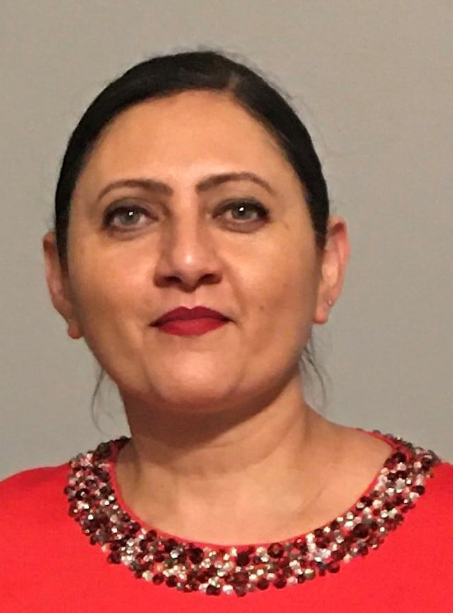
  Jessie Bath is a Planning Senior Business Support Officer, working within the Member Liaison Office for the Planning & Environment area.
  She supports Members, Town & Parish Councils and the Planning & Environment teams to answer questions/enquiries they may have.

Planning & Environment covers the following areas:

- Planning – Development Management
- Planning – Major Developments
- Planning Enforcement
- Planning Policy (i.e. NPPF (National Planning Policy), 5 Year Land Supply, S106, Neighbourhood plans)
- Heritage and Archaeology
- Ecology
- SuDs – Strategic Flood Management
- Building Control
- Highways Development Management
- TPO’s (Tree Protection)
- Landscape and Urban Design

One of the avenues to support communications between Town & Parish Councils and Officers are the Planning Surgeries, which we first set up in August 2023.

Schedules for these are circulated before each quarter, and the surgeries are well worth you attending if you need any Planning & Environment support, or if you just want to know more about the service.

Additionally, and you may already be aware of this, but we hold annual Town & Parish Councils forums, where our Planning & Environment teams give updates on each area and cover any policy or legislative changes you should be aware of.

To find out more about our Member Liaison Officers, email: memberliaison@buckinghamshire.gov.uk

Planning Liaison Surgeries, Q4 ( Sept to Dec 2025)
- Members can request a 20-minute appointment by emailing memberliaison@buckinghamshire.gov.uk , they will receive a Request Booking Form by automatic reply. The Member should then complete the form and return to the email address above.

- The meetings are held via Teams. A link to the online meeting will be included when an invitation is sent to the Member.

- At least two working days’ notice is required to request a Member Liaison Surgery appointment.

Monday 13th October, 10-11.15am – Planning Area 1 Member Surgery Appointments

Monday 27th October, 10-11.15am – Planning Area 1 Member Surgery Appointments

Monday 10th November, 10-11.15am – Planning Area 1 Member Surgery Appointments

Monday 24th November, 10-11.15am – Planning Area 1 Member Surgery Appointments

Monday 8th December, 10-11.15am – Planning Area 1 Member Surgery Appointments

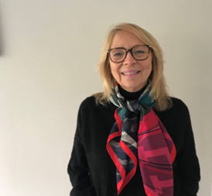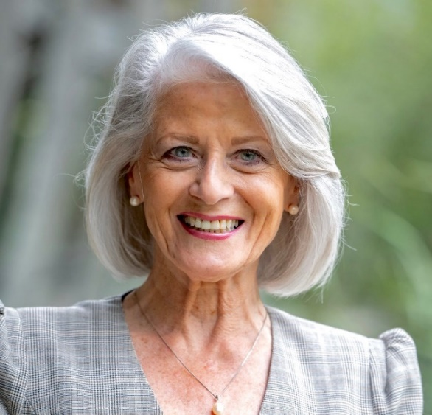

Cllr Caroline Cornell Buckinghamshire Council Cllr Jilly Jordan Buckinghamshire Council
Email: Caroline.Cornell@buckinghamshire.gov.uk Email: jilly.jordan@buckinghamshire.gov.uk
Mobile: 07976853643 Mobile: 07740308468

