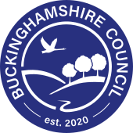
Cllr Jilly Jordan & Cllr Caroline Cornell
Drayton Parslow Parish Council AGM 2026 May 18th 2026

We are pleased to introduce the Annual Report for 2025/26, which reflects the progress we have made during the first year of this new council term. The local elections in May 2025, held under new ward boundaries, reduced the number of councillors from 147 to 97. Caroline Cornell and Jilly Jordan were elected as your new members for the Newton Longville ward which includes Stewkley, Great Brickhill, Swanbourne, Drayton Parslow, Stoke Hammond, Soulbury, Mursley, Dunton and Hogshaw.
In this first year all Members across all political groups have worked together in support of our residents. This collaboration has strengthened our focus on delivering positive outcomes for communities across the county.
At the heart of this report is the difference our services make to people’s everyday lives. Every resident has a stake in the county with a council that is on their side, and it is important that we shine a light on the breadth of support we provide to individuals, families, communities, and businesses across Buckinghamshire. Much of what we do is not always visible, but it keeps our county moving and ensures people can rely on the services they need. I want to recognise the dedication of our staff and partners who deliver this vital work every day.
We continue to operate in an extremely challenging national environment. The demand for public services is rising rapidly, placing intense pressure on councils across the country. At the same time, long-standing funding challenges remain, including reduced funding for Buckinghamshire as resources are directed to other parts of the country.
This makes our focus on value for money and a strong commercial approach more important than ever, reflected this year in the creation of our new commissioning and procurement hub.
Despite these pressures, we have delivered achievements that make a real impact for residents. Our Corporate Peer Challenge in October, led by the Local Government Association, resulted in positive feedback on how we are serving our communities, and the improvement actions identified are already being taken forward.
In July, the Care Quality Commission rated our adult social care services as ‘good’, recognising the knowledge, skill and compassion of our workforce and the strong partnerships supporting residents who rely on these services.
We also launched our Economic Growth Plan, which will help bring new opportunities, investment, and jobs to Buckinghamshire, ensuring that residents benefit from a thriving local economy. And in November, the Council invested an additional £3 million to address the exponential rise in requests for Education, Health and Care Plans, helping to reduce waiting times and strengthen support for children and young people. Ofsted acknowledged this work positively during the Local Area Partnership SEND inspection.
Significant progress has also been made on improving the county’s infrastructure and places. The first phase of the South East Aylesbury Link Road opened this year, easing congestion for local residents and supporting future development. We also delivered the first phase of the Pavilion Quarter regeneration in Aylesbury, with further improvements completed in High Wycombe and Chesham to support vibrant, welcoming town centres.
Alongside this, we have continued to support and expand programmes such as Horizons and Skills Bootcamps, helping residents to access employment, develop new skills and build a stronger future—both within the council and across our wider communities.
Locally
We are pleased to say that we have established and excellent working relationship with members of the parish council and can assure you that they have kept us on our toes. We can’t win every battle. However, we can mention briefly some of the areas where, we are pleased to say, we have been successful
- We have seen improvements to local roads and footpaths, and, yes, we know that the county’s roads need a lot of repair work, but we can assure you that we will work hard to get local issues resolved;
- We have been able to help resolve several issues including planning matters, home to school transport, bus route changes and made some headway on the crossroads. We have helped and in most cases resolve residents queried in a timely manner over the past year.

There will be plenty more to do in the months ahead. The new Buckinghamshire-wide Local Plan is evolving, and we need to keep abreast of it as the draft is refined.
And, of course, there will always be new challenges to face. But we hope too, that we can keep in mind opportunities for positive developments rather than just concentrating on the negatives.

We cannot guarantee to resolve every issue that faces residents of Drayton Parslow and we will be honest with you when we are unable to help, but we can commit to working hard to do the best we can to support you all in your efforts to create and maintain a thriving and cohesive community.
We hope this report sets out the progress we have made as a unitary council over the past year and highlights the work taking place to support our residents and communities in Buckinghamshire.

Email:Caroline.Cornell@buckinghamshire.gov.uk Mobile:07976853643 Email:jilly.jordan@buckinghamshire.gov.uk Mobile: 07740308468

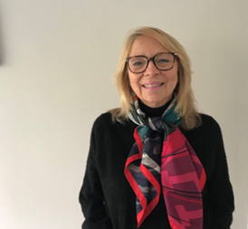Cllr Caroline Cornell

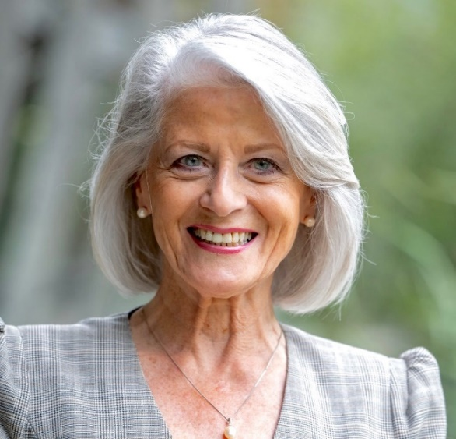 Cllr Jilly Jordan

