Cllr Jilly Jordan & Cllr Caroline Cornell 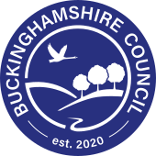

Drayton Parslow Parish Council Meeting, Monday 30th March 2026

Council approves balanced budget for coming financial year
​
Buckinghamshire Council has agreed a balanced budget for the coming year despite increasing financial challenges brought about by national government decisions which mean funds raised locally are being diverted away from Buckinghamshire to other local areas around the country.
The final budget was voted on by full council at a meeting on Wednesday 25 February. It is a legal requirement for councils to put forward a balanced budget, but it has warned it is doing so under increasingly difficult national funding conditions. As a result of the government’s ‘Fair Funding Review’, Buckinghamshire is seeing a reduction in funding of £44.5m as the Government diverts resources away from the county to other geographical areas with higher modelled needs.
Steven Broadbent, Leader of Buckinghamshire Council said: “While I am pleased that we are once again able to bring forward this balanced budget and keep resident priorities top of the list, the Fair Funding Review has placed a further strain on our finances at a time when demand for statutory services continues to grow. We are losing both grant funding and the level of business rates we retain. There is nothing fair about that.
“Our residents are being let down by central government, and we are having to pick up the pieces. The Government assumes that we will raise council tax by the maximum amount when it allocates our funding. Even then, in real terms, this revenue will not go far enough to cover vital services so we will have to work even harder to balance the books in future years.”
Steven continued: “It is only through prudent budgeting in previous years and keeping a continued focus on where we can make savings and efficiencies, that we are making sure that every pound we spend is value for money. We are continuing to prioritise the areas that matter most to residents including investment in roads, maintaining weekly bin collections and funding for education and special educational needs provision. This is alongside our commitment to maintaining and protecting our statutory services which our most vulnerable residents rely on.”
The council has made significant savings to run a balanced budget, totalling £116.8 million in its first five years of operation as a unitary authority. A further £70.5m of savings is expected to be delivered by the end of 2025/26. Additional savings totalling £109m have been identified over the next three years, to allow the council to keep investing in local services as well as providing the critical statutory support services such as social care.
This means that in order to set a balanced budget the total savings made since Buckinghamshire became a unitary authority in 2020 will total £296m, the equivalent of 67% of the council’s budget since 2020.
Some conﬁrmation of some additional grants from the government has been received, however, these are ringfenced grants that can only be spent within certain areas and do not match the funding lost via the Fair Funding Review.
The basic rate of council tax in Buckinghamshire will rise by 2.99 per cent from 1 April 2026, and the Adult Social Care precept will increase by 2 per cent, meaning a total rise of 4.99 per cent, or an extra £1.86 per week for the average Band D home during 2026/27.
Steven continued: “Even with this rise in local tax, the overall ‘core spending power’ - the total funding available to Buckinghamshire Council under the government formula - rises by only 8.2% in the coming three-year period, barely above expected inflation and well below the national average increase of 15.5%.
“We will continue to protect essential services, invest in our communities and maintain our focus on efficiency, value for money and delivering for local people.”

​

Buckinghamshire Council confirms appointment of new Chief Executive
​
Buckinghamshire Council is delighted to confirm the appointment of Zina Etheridge as its new Chief Executive and Head of Paid Service, following the Council meeting held on Wednesday 25 February.
Zina brings extensive senior leadership experience across local government, the NHS and central government. Most recently, she served as Chief Executive of NHS North East London, leading a £6bn integrated health system and overseeing major transformation, financial recovery and innovation benefiting 2.4 million residents.
Before this, she was Chief Executive of Haringey Council, where she delivered major regeneration and housing development projects, improved services and led the borough’s response to the Covid-19 pandemic. Her earlier career includes senior roles at both Haringey and Barnet councils, where she led central services, performance improvement, third sector commissioning and customer services. She has also held strategic leadership roles within the Cabinet Office, working on high-level public service reform.

Steven Broadbent, Leader of Buckinghamshire Council, said:
“I’m delighted that the Council has endorsed Zina’s appointment. She brings a wealth of experience from across local government and the NHS, alongside a strong track record of leading complex organisations through transformation. I’m very much looking forward to working with her as we continue to deliver for our residents.”
Zina will take up the role starting in April 2026

​

Council progresses development of new Local Plan following Government imposition of 95,000 new homes target in Buckinghamshire
​
Buckinghamshire Council is advancing work on a new Local Plan that will provide a framework for how the county grows and develops over the next twenty years.
The emerging plan, a legal requirement – which must demonstrate how Buckinghamshire can accommodate 95,000 new homes to meet Government targets - will set out how it meets future needs for housing, the economy, community facilities and essential infrastructure, while also protecting the county’s precious natural and historic environment.
Steven Broadbent, Leader of Buckinghamshire Council said: “Developing a plan that meets the housing target for Buckinghamshire puts real pressure on our county as 95,000 new homes is 43% higher than requirements under the previous Government’s needs-based methodology. The impact of such development on Buckinghamshire is immense but doing nothing is not an option as having an up-to-date plan is essential to prevent speculative development and ensure infrastructure is properly planned.
“It is a major concern is that these imposed housing numbers do not come with any Government funding for the infrastructure that would be needed to support such growth. While developers will contribute to some of the required investment, this will cover only a fraction of the multibillion-pound costs associated with new roads, transport links, schools, healthcare provision, sewerage systems and energy infrastructure. Central Government will need to step up and plug the gaps if their development targets are to be met.
“The Council remains committed to doing all it can to protect our precious Green Belt and AONB (National Landscapes) and we are adopting a ‘brownfield before greenfield’ approach outside of the Green Belt. In addition, our town centres will have to develop and grow, using current Government methodologies for density, placing even more reliance on existing infrastructure and exacerbating the need for further funding and investment.
To date, over 1,300 residents and stakeholders have taken part in the plan-making process through formal consultation, and a detailed technical assessment of potential development sites has been completed. Of the 1,400 sites identified across Buckinghamshire, approximately 400 are now being published for further engagement and assessment. This next stage of work involves assessing the availability, suitability and viability of these sites with landowners and infrastructure providers.
No decisions on site allocations will be made until this full technical assessment has been completed.
The Council will publish the draft Local Plan this summer for further public consultation. Residents, landowners, infrastructure providers and other partners who would like to provide input in this part of the plan-making process can participate in the council’s site survey https://www.buckinghamshire.gov.uk/sites-survey before 11.59pm on 16 March 2026.

​

Local Plan for Buckinghamshire sites survey

Overview
This survey gives you the opportunity to comment on the availability and suitability of a site identified as being potentially suitable for development under the Local Plan for Buckinghamshire’s plan-making process.
Buckinghamshire is updating its Local Plan in line with national planning requirements ahead of the December 2026 deadline and we are currently engaging with partners and infrastructure providers to help shape the plan, ahead of publication in July.
Having conducted detailed land suitability work, including a Grey Belt Assessment, and a review of more than 1,300 sites identified by communities and the Council, over 400 sites have been identified as potentially suitable.
The Council is now liaising with landowners and infrastructure providers to confirm ongoing site availability and understand the capacity of supporting infrastructure.
Having a Local Plan in place is the best defence against speculative development and ensuring new infrastructure is adequately planned for.
Once adopted, Buckinghamshire’s Local Plan will provide a clear framework for the county’s future development. It will address needs and opportunities relating to housing, the economy, community facilities and infrastructure, while also conserving and enhancing the natural and historic environment, mitigating and adapting to climate change, and securing well-designed places for decades to come.
The plan-making process is well underway with 1,335 residents, businesses and community partners already having shared their views via formal consultation.
The sites that have been assessed on suitability for development can be found on an interactive map.
- when using the map, select the icon in the top left corner (the middle button, with three dots). Sites included in the potential housing and employment supply are shown in turquoise, sites requiring further assessment are dark blue, and sites within the grey belt that are not included in the potential supply are shown in grey.
Before responding to the survey, please also look at the supporting documents and information on the Local Plan for Buckinghamshire web page.
How to have your say
- click on the link below to complete the online survey
- complete, and return, a printed version of the survey (PDF, 224KB)
If you have any questions about this activity, or require this information in another format or language, please email us at planningpolicyteam.bc@buckinghamshire.gov.uk
If you are a landowner of one or more of the sites deemed suitable and you haven’t received a direct written correspondence from us, please email planningpolicyteam.bc@buckinghamshire.gov.uk
Please tell us your views by 11:59pm on Monday 16 March 2026.
Privacy
We will use the information you provide here only for this activity. We will store the information securely in line with data protection laws and will not share or publish any personal details. Survey responses will be analysed using Microsoft products including Copilot, Excel and Word. For more information about data and privacy, please see our privacy policy.
If you have questions about data and privacy, please email us on dataprotection@buckinghamshire.gov.uk or write to our Data Protection Officer at Buckinghamshire Council, The Gateway, Gatehouse Road, Aylesbury, HP19 8FF.
Give us your views
Online Survey
Closes 16 Mar 2026
Opened 17 Feb 2026
Contact
Planning Policy Team
planningpolicyteam.bc@buckinghamshire.gov.uk
The Local Buckinghamshire Council

Council launches consultation on Local Transport Plan 5
​
Buckinghamshire Council is inviting residents, businesses and visitors to take part in a public consultation on the draft Local Transport Plan 5 (LTP5), running from 16 February to 30 March 2026.
LTP5 sets out how the council aims to make travelling around Buckinghamshire easier, safer and more accessible, while improving travel choices for all. The plan looks ahead to 2045 and will guide how transport improvements are planned, funded and delivered across local communities, the road network and public transport over the next 20 years.
The draft plan brings together 31 policies across nine themes, focused on connecting the economy, reducing transport emissions and creating high-quality places. These policies are intended to steer future investment and day-to-day decisions that affect town centres, villages and local high streets.
Alongside the draft LTP5, the council is also seeking views on the draft Freight and Logistics Strategy, which looks at practical ways to manage goods and deliveries so that streets work well for residents, businesses and the environment.
Consultation feedback will help the council balance priorities such as road safety and maintenance, bus and rail connectivity, walking, wheeling and cycling, and the way town and village centres are designed to support local communities and businesses. Responses will also be fed into the plan-making process for the Local Plan for Buckinghamshire, currently expected to reach Regulation 19 consultation in July 2026.
How to take part
- Read the draft documents and complete the online survey at: https://yourvoicebucks.citizenspace.com/integrated-transport/ltp5
- Email: transportstrategy@buckinghamshire.gov.uk
- Write to: Draft LTP5 consultation, Transport Strategy, Buckinghamshire Council, Walton Street, Aylesbury, HP20 1UA
The consultation closes at 11:59pm on 30 March 2026.
Feedback will be used to update LTP5 and the Freight and Logistics Strategy. The amended documents and supporting evidence are scheduled to be submitted to the Council’s Cabinet for adoption in summer 2026.
Responses will also inform work on the Local Plan for Buckinghamshire (planned July 2026).

Ofsted inspection of SEND services in Buckinghamshire
​
In November 2025, we welcomed Ofsted for an inspection of our Special Education Needs and Disability (SEND) services in Buckinghamshire. The inspection reviewed the Buckinghamshire Local Area Partnership, which includes Buckinghamshire Council and the Buckinghamshire, Oxfordshire and Berkshire West Integrated Care Board (BOB ICB) and well as other partners in education, health and care services.
The inspection team spent three weeks in November 2025 carrying out the Area SEND Inspection which focuses on how local partners across the council, health and social care sector work together to improve the experiences and outcomes of children and young people with SEND.
The report outcome indicates that the Buckinghamshire Local Area Partnership arrangements lead to inconsistent experiences and outcomes for children and young people with SEND. This equates to a level two judgement on a three-level scale. The local area partnership must work jointly to make improvements.
We know that many families in Buckinghamshire continue to face significant pressures navigating the SEND system, and we remain fully committed to improving services and outcomes so children and young people get the support they need to thrive.
The service was last inspected in 2022 and the inspection team recognised a range of areas where meaningful progress has been achieved. These include:
- Stronger leadership and governance
- Higher quality EHC plans
- Good support for disabled children
- Improvements to early years services
- Better accessibility and consistency in therapy services
- Well-coordinated wraparound support for children and young people with complex needs
- Improved joint working to support young people to prepare for adulthood
Overall, inspectors concluded that the partnership’s strategic priorities are the right ones and the transformation work already underway is moving the system in the right direction, but improvement needs to take place with greater pace and consistency, alongside improved communication and more robust quality assurance.
Following on from the publication of the report an action plan is being developed to address the points raised.
To view the full Ofsted inspection report visit the website.
The inspection acknowledges genuine progress across the partnership and validates the direction of travel of our existing SEND Improvement Programme. It also provides a clear mandate to accelerate and deepen improvements so that children, young people and families experience consistent, high-quality support at every stage quality support at every stage.
Local Area Partnerships are made up of those in education, health and care who are responsible for planning, commissioning, managing, delivering and evaluating support for children and young people with SEND who live in a local area.”

Town and Parish Council customer service VIP line

You can make contact with us via the following email address: parishsupport@buckinghamshire.gov.uk
There is a dedicated Town and Parish Council customer service VIP phoneline where you can reach a member of our customer team on 0300 303 5640, 9am to 5:30pm Monday to Thursday, and 9am to 5pm on Friday.
Jessie Bath, Member Liaison Officer
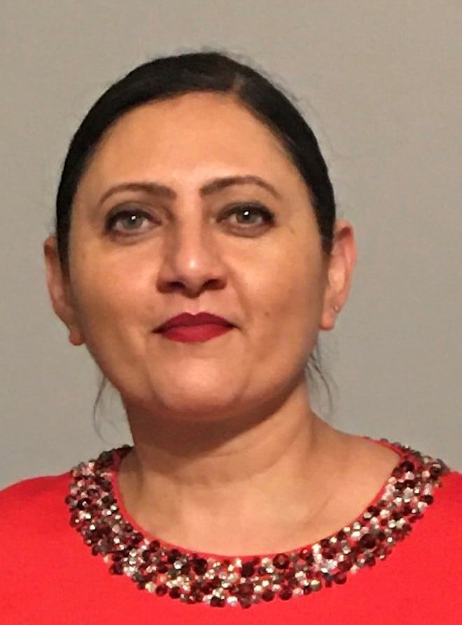
  Jessie Bath is a Planning Senior Business Support Officer, working within the Member Liaison Office for the Planning & Environment area.
  She supports Members, Town & Parish Councils and the Planning & Environment teams to answer questions/enquiries they may have.

Planning & Environment covers the following areas:

- Planning – Development Management
- Planning – Major Developments
- Planning Enforcement
- Planning Policy (i.e. NPPF (National Planning Policy), 5 Year Land Supply, S106, Neighbourhood plans)
- Heritage and Archaeology
- Ecology
- SuDs – Strategic Flood Management
- Building Control
- Highways Development Management
- TPO’s (Tree Protection)
- Landscape and Urban Design

One of the avenues to support communications between Town & Parish Councils and Officers are the Planning Surgeries, which we first set up in August 2023.

Schedules for these are circulated before each quarter, and the surgeries are well worth you attending if you need any Planning & Environment support, or if you just want to know more about the service.

Additionally, and you may already be aware of this, but we hold annual Town & Parish Councils forums, where our Planning & Environment teams give updates on each area and cover any policy or legislative changes you should be aware of.

To find out more about our Member Liaison Officers, email: memberliaison@buckinghamshire.gov.uk

Planning Liaison Surgeries, Q2 (Apr-June)
- Members can request a 20-minute appointment by emailing memberliaison@buckinghamshire.gov.uk , they will receive a Request Booking Form by automatic reply. The Member should then complete the form and return to the email address above.

- The meetings are held via Teams. A link to the online meeting will be included when an invitation is sent to the Member.

- At least two working days’ notice is required to request a Member Liaison Surgery appointment.

Please contact the dedicated Town and Parish Council customer service VIP phoneline where you can reach a member of our customer team on 0300 303 5640, 9am to 5:30pm Monday to Thursday, and 9am to 5pm on Friday for a date if required
Current Dates:

Planning Town & Parish Representative Liaison Surgeries (April - June 2026)

- Monday 13 April, 10-11.15am – Planning Area 1 Surgery Appointments

- Monday 27 April, 10-11.15am – Planning Area 1 Surgery Appointments

- Monday 11 May, 10-11.15am – Planning Area 1 Surgery Appointments

- Tuesday 26 May, 10-11.15am – Planning Area 1 Surgery Appointments

- Monday 8 June, 10-11.15am – Planning Area 1 Surgery Appointments

- Monday 22 June, 10-11.15am – Planning Area 1 Surgery Appointments



Cllr Caroline Cornell Buckinghamshire Council Cllr Jilly Jordan Buckinghamshire Council
Email: Caroline.Cornell@buckinghamshire.gov.uk Email: jilly.jordan@buckinghamshire.gov.uk
Mobile: 07976853643 Mobile: 07740308468

